**LINGI 2315 - Evaluation 1 - Bare-metal Project P1**

|  |  |  |  |
| --- | --- | --- | --- |
| Name | Delcoigne Ben | Noma | 38771700 |

Description of the software that implements the first question

I set a global variable “current_switch” which knows what state the switches are in at all times. It defaults to 0.   
When a switch is pressed, an interrupt is raised (using code from hw)

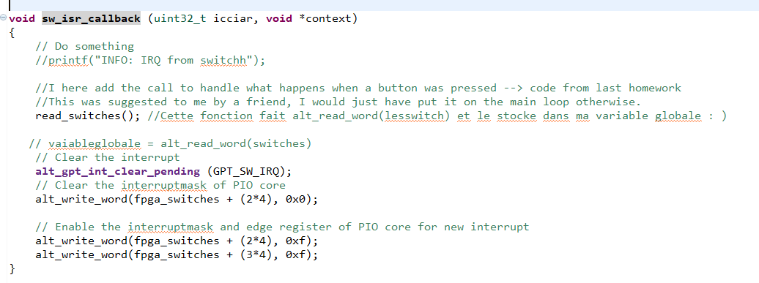The function read_switches simply reads the value of the switches and stores it into the global variable **current_switch.**

This closes the part about updating the active switch correctly.

Now lets have a look at the display on the LED’s:

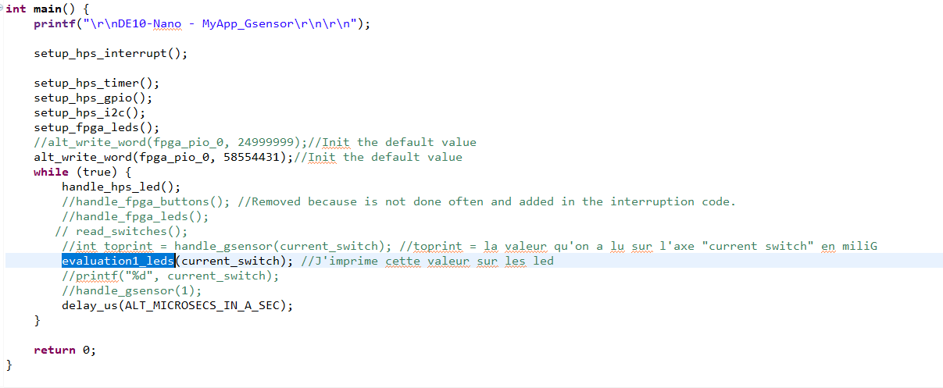

My main function calls the function evaluation1_leds with the current switch value as a parameter.

ere is the code of that function:

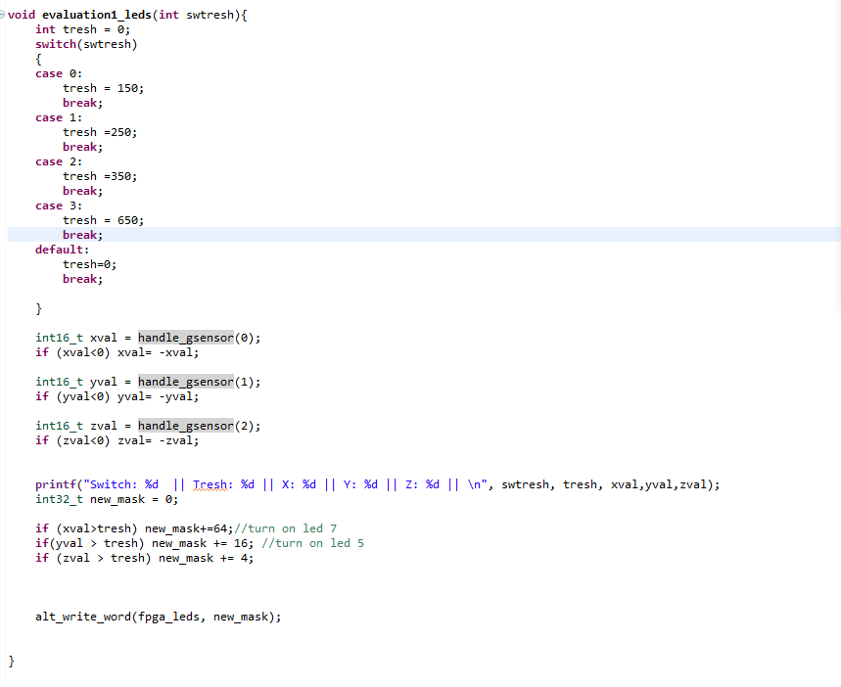

As you see, I set the treshold according to the switch value. I then read x, y and z from the accelerometer using handle_gsensor. This function was created by the assistants for the homework, I just extract the x, y and z axis. (code below).

Once done, I set the LED mask using binary values associated to the mask.

**NOTE:** Nicolas Chavaux evaluated me and as I showed him, for an unknown reason, the X axis seems to have an unconsistent reading. The code does the same for the three axis so there is no software reason it wouldn’t work. I flashed the fpga several times but the error persists.

**LINGI 2315 - Evaluation 1 - Bare-metal Project P2**

Description of the hardware & software that implement the second question (C, Verilog, Qsys)

APPENDIX FROM PART 1:

Code of handle_gsensor:

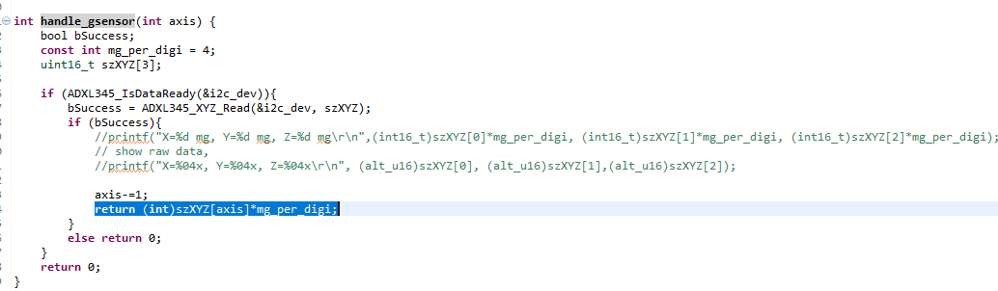

---------------------------------------PART 2 -------------------

1/ Set the PIO to 32 bits in the platform designer

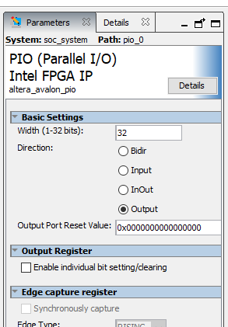

2/ Change the verylog

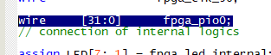Only the number of bits was changed in the wire.

3/ Compile the design. Once done, generate the .h file and transfer it into the gsensor Eclipse project

In the C code, I set the default value to 249999 before, now, to take advantage of the 32 bits, I set it to 58554431

